Chapter 12, Solution 65.

Due to the delta-connected source, we follow Example 12.12. We type Total Pts = 1, Start Freq = 0.1592, and End Freq = 0.1592. The schematic is shown below. After it is saved and simulated, we obtain an output file which includes

FREQ IM(V_PRINT1) IP(V_PRINT1)

1.592E-01 1.140E+01 8.664E+00

FREQ IM(V_PRINT2) IP(V_PRINT2)

1.592E-01 1.140E+01 -1.113E+02

FREQ IM(V_PRINT3) IP(V_PRINT3)

1.592E-01 1.140E+01 1.287E+02

Thus, I_{aA} = 11.02∠12° A, I_{bB} = 11.02∠–108° A, I_{cC} = 11.02∠132° A

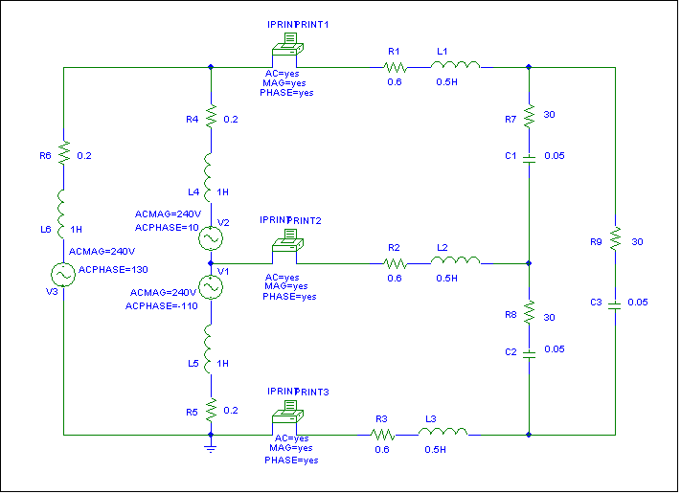

Since this is a balanced circuit, we can perform a quick check. The load resistance is large compared to the line and source impedances so we will ignore them (although it would not be difficult to include them).

Converting the sources to a Y configuration we get:

V_{an} = 138.56 ∠–20˚ Vrms

and

Z_{Y} = 10 – j6.667 = 12.019∠–33.69˚

Now we can calculate,

I_{aA} = (138.56 ∠–20˚)/(12.019∠–33.69˚) = 11.528∠13.69˚

Clearly, we have a good approximation which is very close to what we really have.

